[IMA-23] Instagram limits the bio to 150 characters, but it limits me to write 124 characters

Created: 10/Sep/24 Updated: 10/Sep/24
Status: | To Do
Project: | Instagram Mobile App

Type: | Bug | Priority: | Medium
Reporter: | Tomer Darmon | Assignee: | Unassigned
Environment: | OS : Android  Device : One Plus 11 5G OS Version : Android 14

Attachments: | 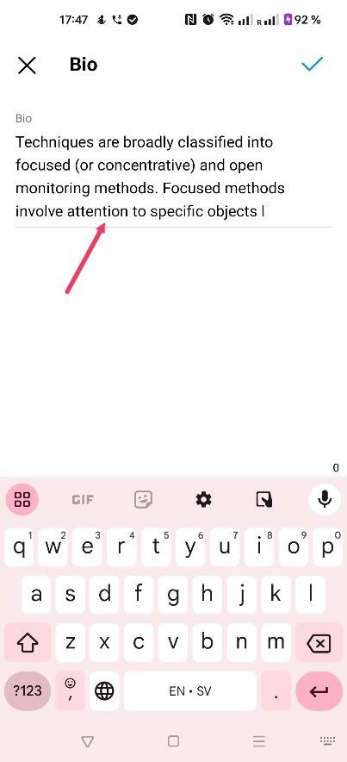
Severity1: | S3 - Major

Description
Steps to Reproduce :
- Enter the "Instagram" app
- Press on your "Profile" icon at the bottom right
- Tap on the tab "Edit profile" at the top left
- Chose the "Bio" section and write a bio
- Press on the "Checkmark" at the top right once you finished
Actual Result :
"Instagram" limits my "bio´s" writing after only 124 characters without a notification while the limit is until 150 characters
Expected Result :
I will expect that "Instagram" won´t limit me under 150 characters according to its last update

42

